TABLE OF CONTENTS

- SETTING
- LORE
- CHARACTERS

SETTING
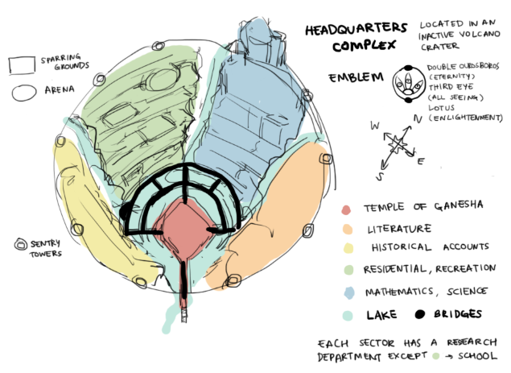

o Temple of Ganesha - Most people in the library are Hindi (not religious though) they don’t really worship any of the other gods apart from ganesha though, they follow the story of parvati creating ganesha out of clay and being too beautiful so shiva beheaded him and replaced his head with that of an elephant’s, and so ganesha created the monsters in the books to lash out against shiva??
not the only temple, east library also has a small temple dedicated to saraswati

o Literature (EAST LIBRARIES) - The most massive collection of literature in the world, mostly classics from established authors all over the world. Most of this sector is used to store old original texts regarding the arts & philosophy, including studies of the arts, but there’s a smaller library (not really small, but small compared to the rest of the sector) that people from other sectors can use to borrow books that have already been translated into the common language! Also has a small temple dedicated to Saraswati, the goddess of the arts. There’s maybe a performing hall here for plays and concerts!! The second liveliest sector, used to function as a smaller additional residential sector. The creatures first started appearing here, in an event called [ The Advent ] and this sector, which had bustled with life before, now stands desolate and blocked off from the other sectors. After years of research and training, people called bookkeepers now fight in order to reclaim the East Libraries. Currently, only a very small part of this sector has been reclaimed.

o Historical Accounts (SOUTH LIBRARIES) - One of the most complete collections of historical accounts in the world. Part of it is dedicated to unbiased historical reviews, but the majority of storage space is for personal records of happenings in defining historical events in the world. Libraries within this sector are grouped in regions.. YA mostly basic history since history can never be too comprehensive. Research is done mostly to translate, compile and sort new texts they’ve received from the outside world. Not very affected by [ The Advent ].

o Residential, Recreation (WEST SECTOR) - Almost like a town, most of the people who work in the libraries live here, there’s also a farm here to feed all the people/clothe them.. since they’re hindu they believe in reincarnation, so all of them are vegan. population here is around 300 people?? there is also a school for basic education before they start working in the different sectors. There’s a huge paper factory and printing press near the farm, downstream to prevent contamination of the farms above it. Arenas and sparring areas are newly built after [ The Advent ], people keep books in cages and release them for people to watch them fight as entertainment. A small district of slums were also built to cope with the influx of people from the East Libraries after it became uninhabitable.

o Mathematics, Science (NORTH LIBRARIES) - The place where most of the research takes place, has records of astrology and extensive documentation of experiments that have been conducted, theorems regarding the universe, etc. Many research facilities here, regarding how to preserve ancient books and scrolls longer, such as sealants, dehumidifying containers, etc. Also researches how to make new books and scrolls last longer. After [ The Advent ], they started researching more durable armor, weaponry and fighting styles in conjunction with the South Libraries. The castle at the top used to be a place for the scientists to conduct particularly dangerous experiments, but resources have now been shifted. It has been converted into a training academy for Bookkeepers.

o Lake - Three rivers from melted ice caps flow down from three other mountains in the mountain range to the crater, which culminates into a lake at the very bottom of the crater, which then flows down as another river at the least steep part of the volcano. Parts of the lake are shallow enough and clear enough to splash in, like the areas near the bridges, but the temple was built over a hole that no one who has explored too deeply has returned above the surface of the water to talk about.

o Bridges - only one pathway in and out, which is a small and narrow bridge at the least steep part of the crater/mountain, also from top view looks sort of like a lotus.

LORE

[ The Advent ] (i made this all up by the way >_<)

In the beginning, Parvati, one of the highest goddesses, was lonely because her husband, Shiva, the greatest god, was constantly busy. Parvati then created Ganesha, a bright god who gained the adoration of the rest of the gods due to his handsomeness, great sense of humor, wisdom, and intelligence. Ganesha made the first library for humans because he wanted to share his love of learning with everyone, in a volcanic crater in the mountain ranges of India. The library was called Ganesha’s Cradle, and people everywhere celebrated it.

Centuries passed, and Parvati began to fall enchanted with Ganesha. Ganesha, however, was clueless to her affections. Her husband, Shiva, grew jealous, and beheaded Ganesha. However, upon understanding that Ganesha had harbored no romantic inclinations for Parvati, and remembering how Ganesha had truly been a good god, but knowing that his wife would fall for him again, he replaced Ganesha’s original head with that of an elephant’s to make sure that no one would ever fall in love with Ganesha again. Legends then circulated that Shiva had thrown Ganesha’s original head down from the heavens to the earth, but no one knows where it had fallen.

When Ganesha was reborn, enraged by the wrong done to him, he channelled his bitterness as [ The Advent ], destroying the peace of the human world. Creatures, nightmarish and monstrous, started to become real from the stories they originated from, beginning an age forbidding fiction books from being written ever again. The first library, Ganesha’s Cradle, is now solely dedicated to ridding the world of its founder’s wrongdoing.

Bookkeepers

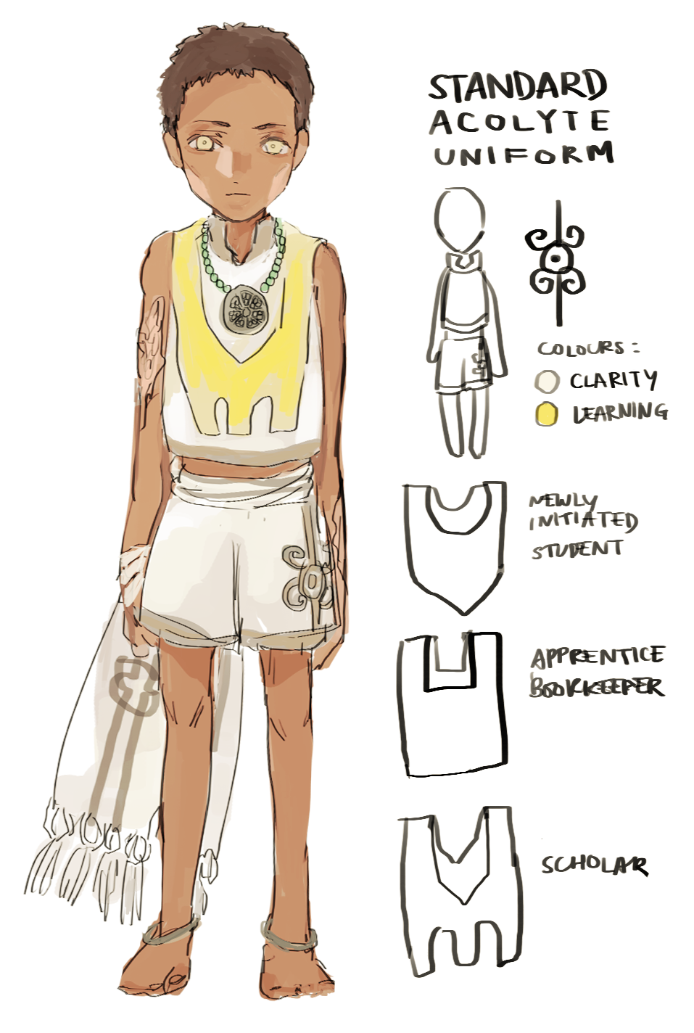
People who fight the creatures in the books, considered reckless by some and heroes by others. The Bookkeepers can also enter books to rescue people who were dragged into the books by the creatures.

Creatures (come up with a better name omg)

The monsters that appeared from books after the advent

Silverfish

Speculated to have descended from the yearnings for knowledge from Ganesha’s beheaded original head that fell to earth, eats the words in books.

Extras:
Children under the age of 16 wear the same kind of clothes: (that’s baby divyesh by the way) ->

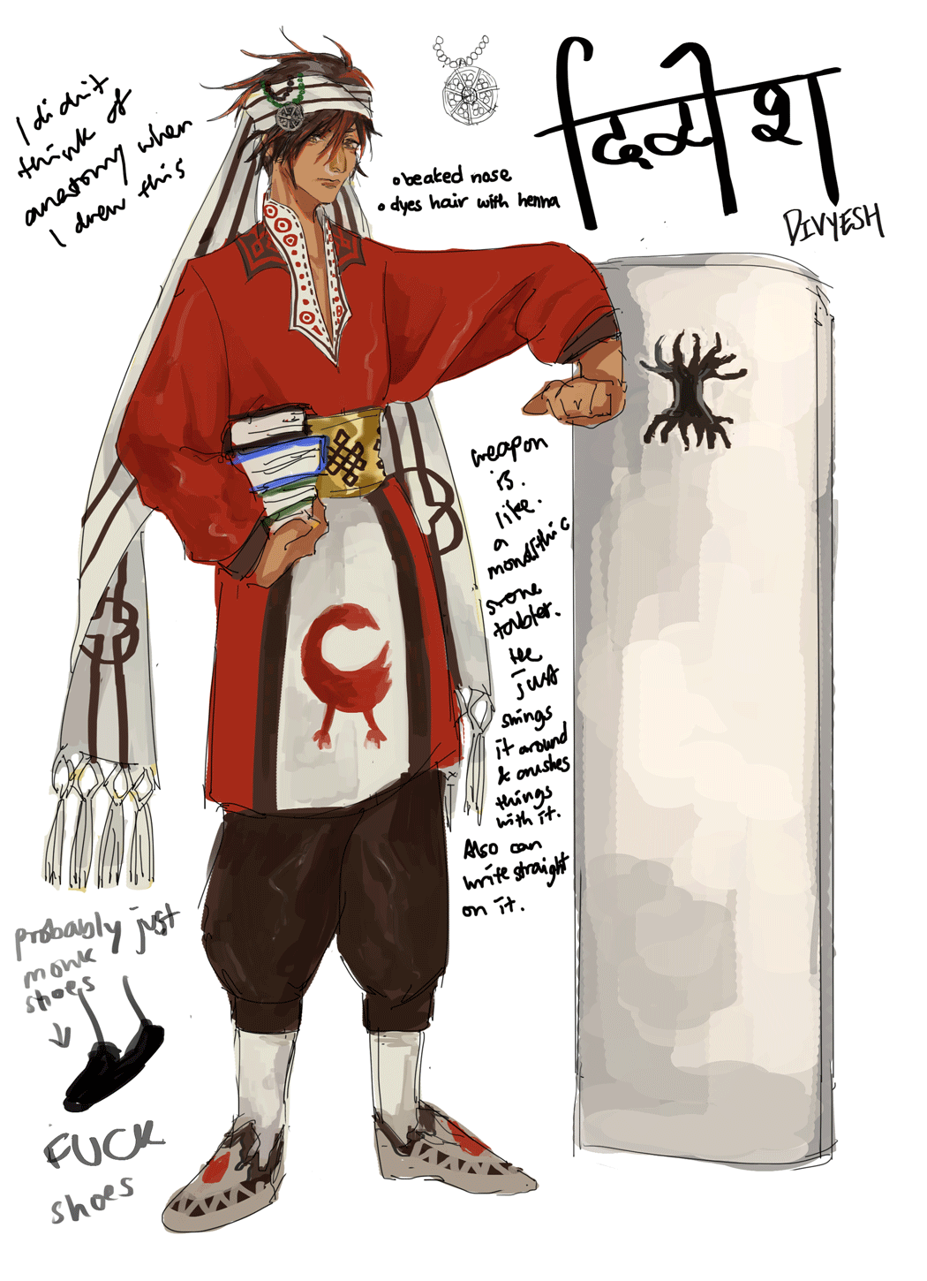
CHARACTERS

DIVYESH दिव्येश

PERSONALITY: badass baby, pretty stoic most of the time..

HISTORY:
when he was younger he was found as an orphan left in a reed basket, swaddled in a scarf with a jade bead necklace with a stone disc wrapped around him, floating on the lake near the temple of ganesh.. a priest spotted him and, shocked, fished him out, took care of him. the priest wanted him to follow in his footsteps, but divyesh was too curious a child about learning and ended up escaping and spending most of his days in the south libraries in his thirst for knowledge (and maybe to find the history of his origin). this is where the coldness in his personality comes from ( he has to distance himself from his emotions to deal with all the firsthand accounts of atrocities he has read of. but he still empathizes, perhaps a bit too much, so he closes himself off). he joined the fight to reclaim the east libraries because he was assigned by the southern libraries to record the happenings as an unbiased historian. first person to get a rise out of him in a long while was kavi!! got assigned to him too!! fun things happen!!
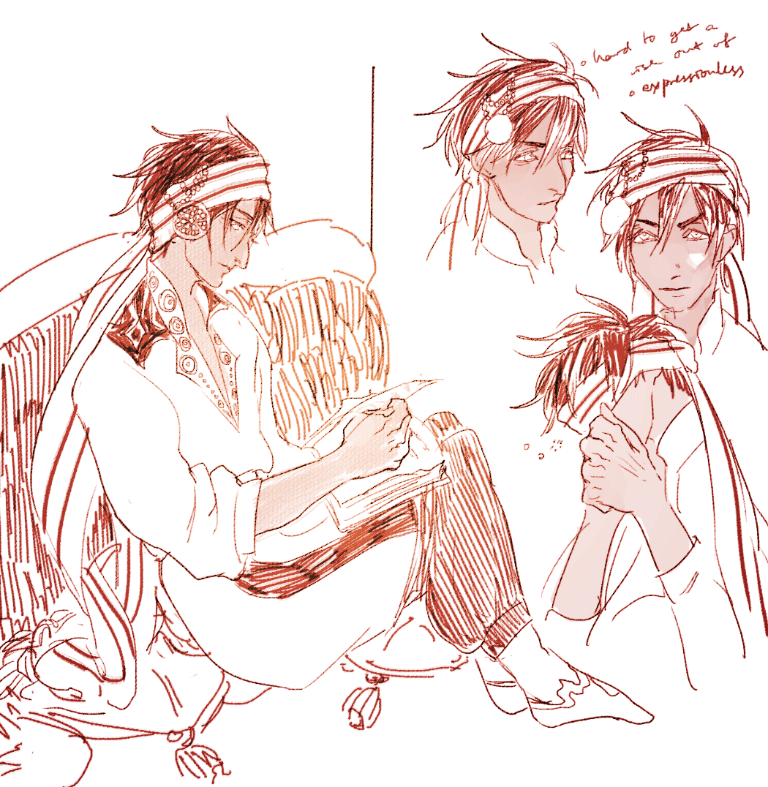
HEIGHT: 1.83m

WEIGHT: 81.4 kg (when he was young he was pretty skinny but he’s solidly built now)

